Monthly Progress Report
Development and Validation of Silver-Coated Silicon SERS Substrate Using Rhodamine 6G (R6G)
Reporting Period: June/2026
1. Introduction
During this reporting period, significant progress was achieved in the fabrication, optimization, experimental validation, and computational analysis of a silver-coated silicon Surface-Enhanced Raman Scattering (SERS) substrate. The primary objective was to establish a reliable and reproducible SERS platform using Rhodamine 6G (R6G) as a standard Raman probe molecule before extending the methodology to the detection of N-Acetylmuramic Acid (NAM), an important bacterial biomarker for sepsis diagnosis.
The work involved substrate fabrication through hydrofluoric acid (HF) etching followed by silver nanoparticle deposition, Raman spectral acquisition under multiple experimental conditions, extensive spectral preprocessing, and Density Functional Theory (DFT)-based theoretical validation using Gaussian 16.

2. Experimental Work Completed
The following experimental activities were successfully completed during this month:
• Silicon Substrate Fabrication
A single-side polished phosphorus-doped n-type silicon wafer (100 orientation) was used as the substrate material. The silicon surface was chemically etched using hydrofluoric acid (HF), followed by galvanic displacement deposition of silver nanoparticles to produce a nanostructured Ag/Si SERS substrate.
Different fabrication conditions were investigated by varying:
- HF concentration
- Silver deposition time
- Sample preparation conditions
Eight different substrate fabrication conditions were prepared and evaluated.
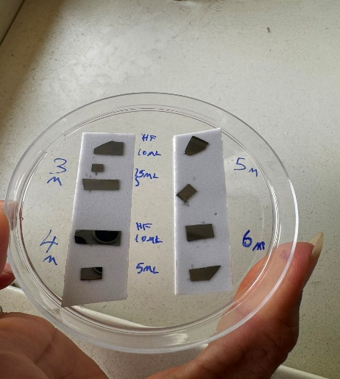
• Raman Measurements
The fabricated substrates were tested using Rhodamine 6G (R6G) solution as the Raman probe molecule.
Approximately 97 Raman spectra were collected under different experimental conditions.
The spectra were evaluated based on
- Signal intensity
- Signal-to-noise ratio
- Peak reproducibility
- Baseline quality
Among all fabricated substrates, one condition exhibited the highest Raman enhancement and was selected for further analysis.

Figure 1
Fabrication workflow of the Ag-coated silicon SERS substrate.
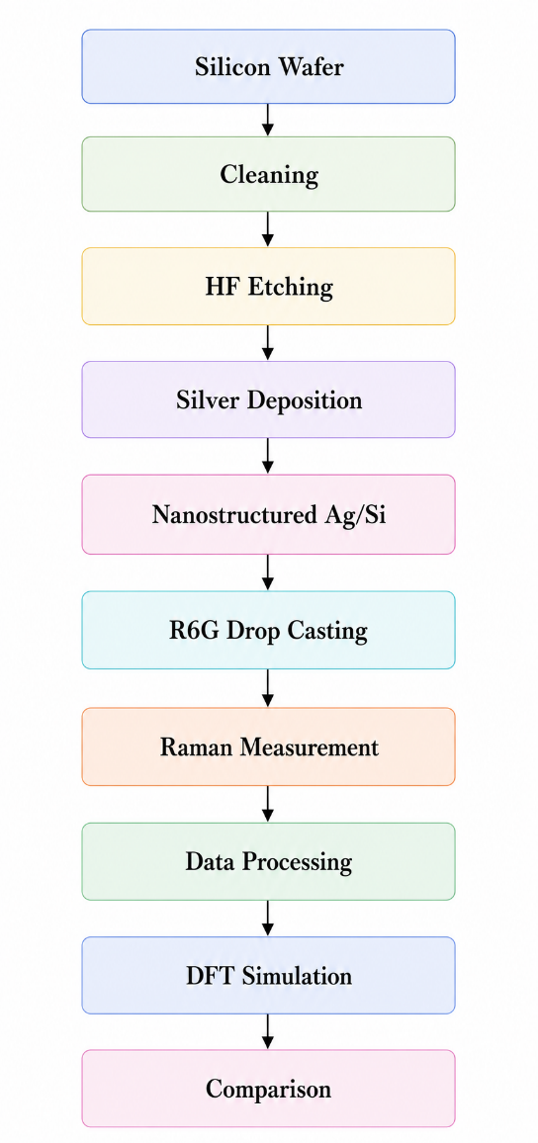
3. Raman Data Processing
Raw Raman spectra contained fluorescence background, random CCD noise, and cosmic ray spikes. Therefore, a complete preprocessing workflow was developed before comparison with theoretical calculations.
The processing pipeline included:
- Cosmic ray removal
- Baseline correction using Asymmetric Least Squares (ALS)
- Savitzky–Golay smoothing
- Vector normalization
- Quality control of all spectra
Different preprocessing methods were compared, and ALS baseline correction combined with Savitzky–Golay smoothing produced the best spectral quality while preserving Raman peak positions.
After preprocessing, the experimental spectra showed well-defined characteristic Raman peaks of Rhodamine 6G with significantly improved signal-to-noise ratio.

Figure 2
Representative preprocessing stages showing raw spectrum, baseline correction, smoothing, and normalized Raman spectrum.
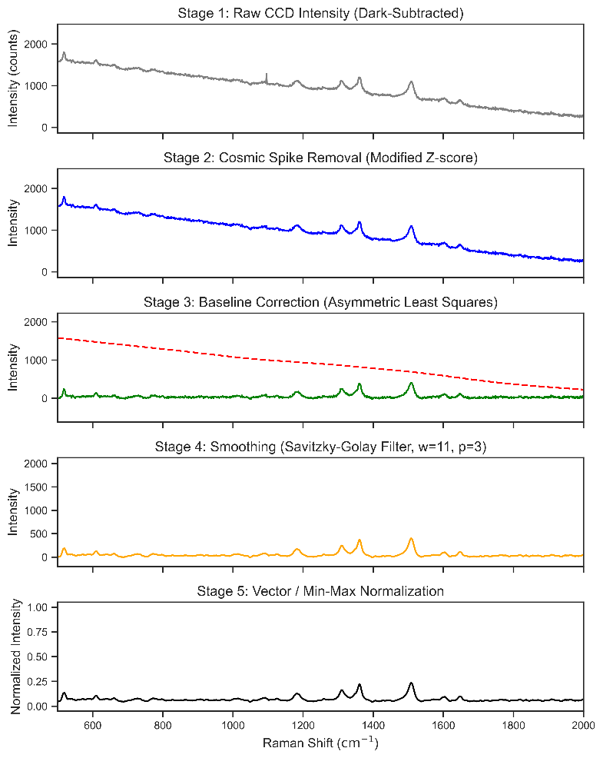
4. Experimental Results
The optimized Ag/Si substrate produced strong and reproducible SERS enhancement for Rhodamine 6G.
The major experimental Raman bands were observed near
- ~610 cm⁻¹
- ~773 cm⁻¹
- ~1184 cm⁻¹
- ~1312 cm⁻¹
- ~1361 cm⁻¹
- ~1509 cm⁻¹
- ~1650 cm⁻¹
These characteristic peaks correspond to various vibrational modes of the xanthene ring structure of Rhodamine 6G and agree well with previously reported Raman spectra.
The processed experimental spectrum exhibited excellent peak resolution with minimal baseline interference, demonstrating successful substrate fabrication and optimized experimental conditions.

Figure 3
Final processed experimental SERS spectrum of Rhodamine 6G showing the characteristic Raman fingerprint peaks.

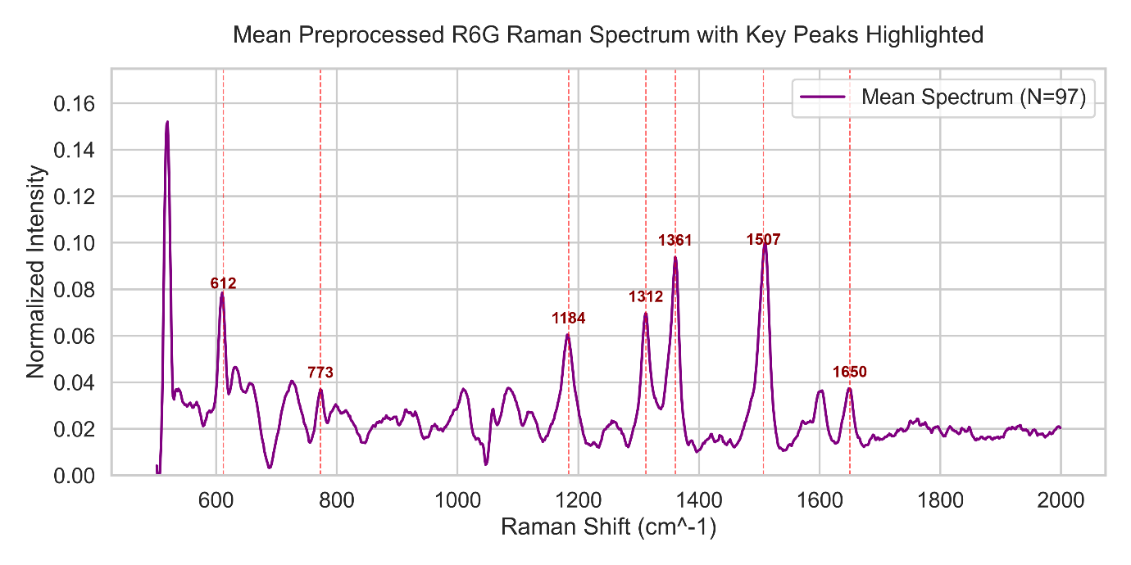

5. Density Functional Theory (DFT) Validation
To validate the experimental observations, theoretical Raman spectra were calculated using Gaussian 16.
The computational methodology included:
- Geometry optimization
- Frequency calculation
- Raman activity calculation
using
- B3LYP functional
- 6-311++G(d,p) basis set
The calculated harmonic frequencies were corrected using the literature scaling factor of 0.967 before comparison with the experimental Raman spectrum.
Lorentzian broadening was applied to generate a continuous theoretical Raman spectrum comparable to the experimental data.
Peak-by-peak comparison demonstrated excellent agreement between experimental and theoretical Raman frequencies. Minor deviations are attributed to harmonic approximation, experimental conditions, and surface-enhanced Raman effects arising from silver nanoparticle interactions.
The statistical validation showed very strong correlation between theoretical and experimental Raman frequencies, confirming the reliability of the fabricated SERS substrate and the computational methodology.

Figure 4
Comparison of experimental Raman spectrum with scaled DFT simulated spectrum showing peak-to-peak agreement.
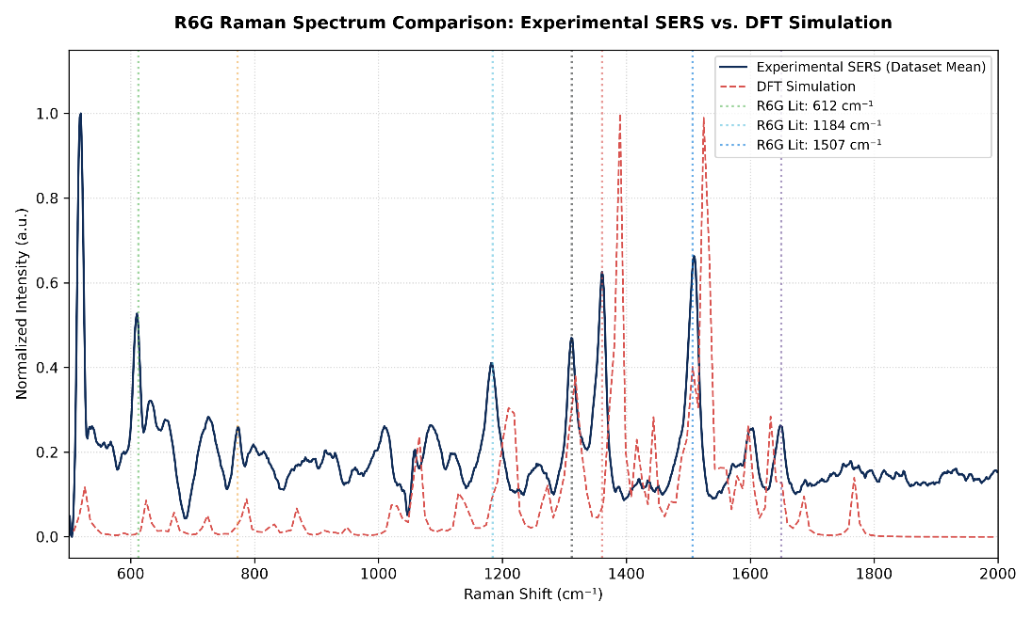

6. Major Outcomes Achieved
The following milestones were successfully completed during this reporting period:
- Successfully fabricated nanostructured Ag-coated silicon SERS substrates.
- Optimized fabrication parameters through multiple experimental conditions.
- Acquired and quality-controlled 97 Raman spectra.
- Developed a complete Raman preprocessing workflow including cosmic ray removal, baseline correction, smoothing, and normalization.
- Obtained high-quality Raman spectra with clear Rhodamine 6G fingerprint peaks.
- Performed DFT Raman simulations using Gaussian 16.
- Successfully validated experimental Raman spectra through comparison with theoretical calculations.
- Established a reproducible workflow for future Raman-based biosensing studies.

7. Preliminary NAM Experiments and Future Optimization
During the current reporting period, preliminary Surface-Enhanced Raman Scattering (SERS) experiments were carried out using N-Acetylmuramic Acid (NAM) at different concentrations on the optimized Ag/Si SERS substrate. The objective was to evaluate the applicability of the fabricated substrate for detecting NAM as a potential bacterial biomarker.
Different NAM concentrations were prepared and analyzed under the optimized Raman acquisition conditions established using Rhodamine 6G. Although Raman spectra were successfully collected, no distinct or reproducible characteristic NAM peaks with sufficient intensity were observed. Therefore, the preliminary experiments did not yield satisfactory SERS signals for reliable spectral analysis.
The initial results indicate that further optimization of the experimental conditions is required before successful NAM detection can be achieved. Possible factors affecting the measurements include insufficient adsorption of NAM molecules onto the silver nanostructured surface, concentration effects, sample preparation methodology, and Raman acquisition parameters.
Based on these observations, the next phase of the research will focus on systematic optimization through:
- Investigating a broader range of NAM concentrations.
- Optimizing sample preparation and drop-casting protocols.
- Refining Raman acquisition parameters, including laser power, integration time, and number of accumulations.
- Optimizing substrate preparation and surface conditions to improve analyte adsorption and SERS enhancement.
- Repeating SERS measurements after optimization to obtain reproducible and well-defined NAM Raman spectra.
These optimization studies are expected to improve the sensitivity and reproducibility of the fabricated Ag/Si SERS substrate and establish a reliable protocol for NAM detection, thereby supporting its future application in bacterial biomarker detection for sepsis diagnosis.

